Vimala K
192424276

Write a C++ program to display student details using a function with default arguments.

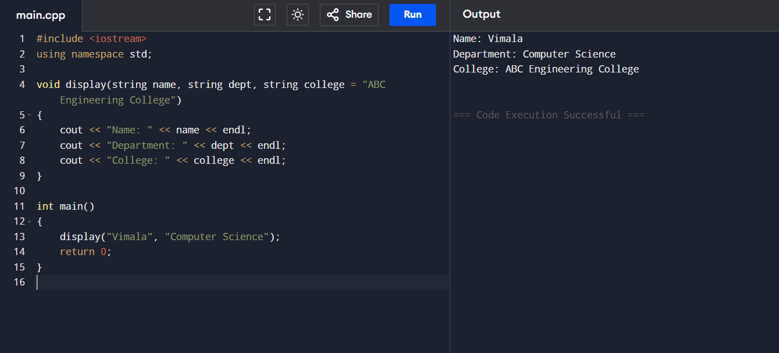

Write a C++ function to calculate the area of a rectangle using default arguments.

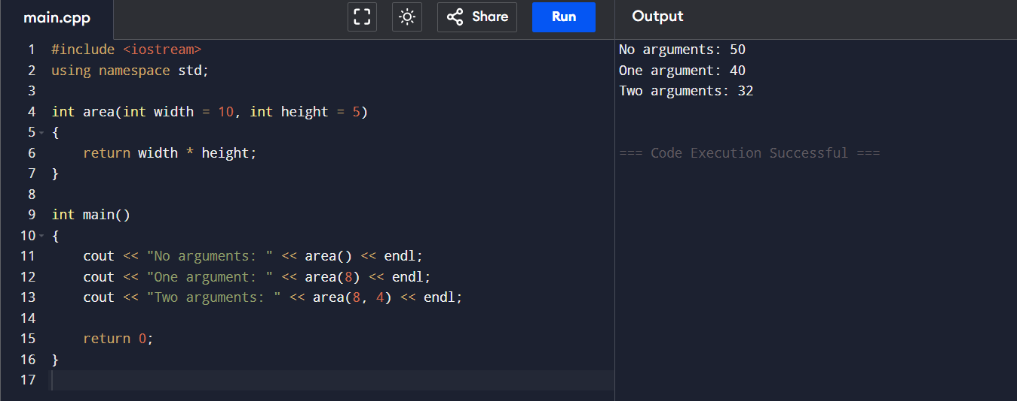

Write a C++ program to overload the function max() to find:

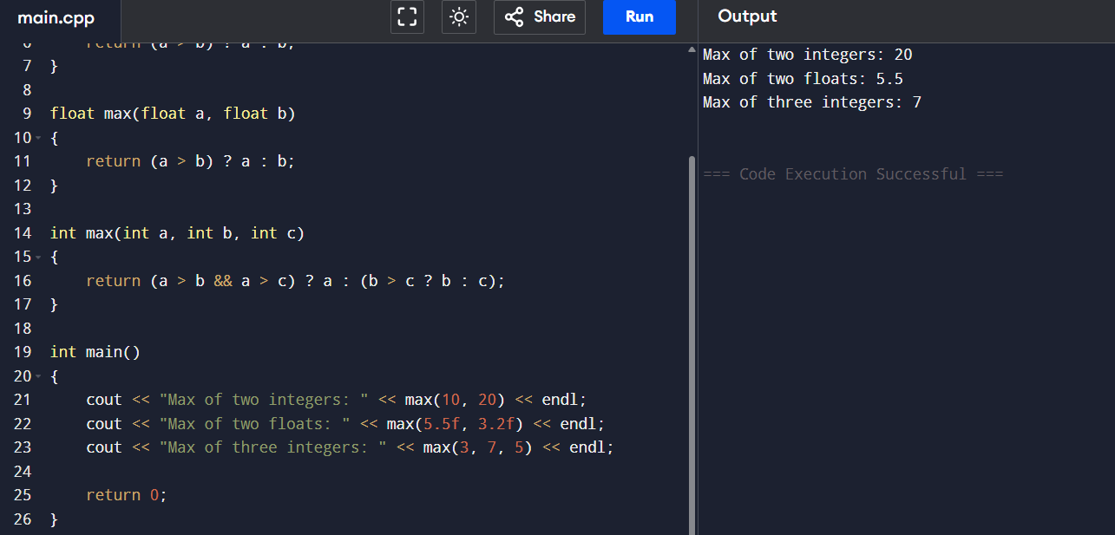

Write a C++ program to implement a class BankAccount with the following details:

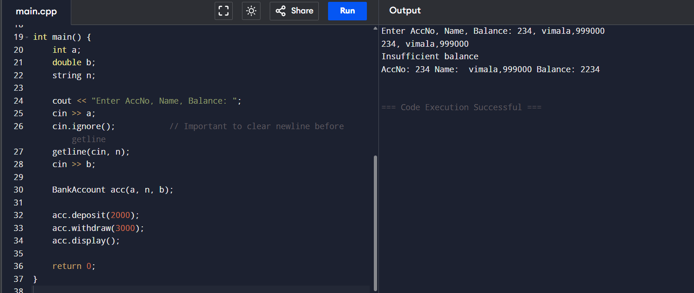

Write a C++ program to create a class Employee with the following details:

